**Lab Assignment Day2**

1. Use grid layout with your CV page design, and make sure that it’s completely responsive (use viewport meta tag):
   1. Use 16 columns layout.
   2. Set box-sizing property.
   3. Use Viewport units with the text in the header, and max-width with the image.
   4. Use float property or Use flex instead of float.

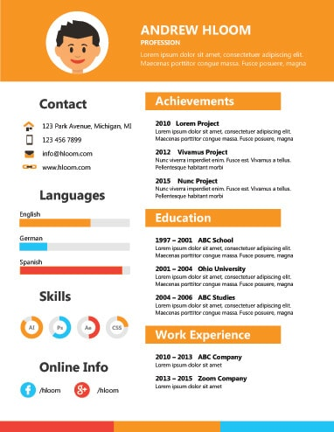

2-Make a Demo in Sass in any page.

* Try Scss syntax for variables, mixins, nesting ,extend and import.
* Compile it using command line or visual code extension
* Link the generated css to your HTML page.